**Predicting Tuberculosis Trends in India: A Time Series Forecasting Approach**

**ABSTRACT**

Tuberculosis, a fatal infectious disease caused by Mycobacterium tuberculosis, spreads through aerosol droplets from active cases. Globally, it results in approximately 9 million new cases and 1.7 million deaths annually. This study aimed to investigate seasonal patterns in TB incidence in India and develop a univariate model for monthly TB incidence over the past seven years and six months using available data. A set of time series analysis was performed using the active TB cases nationwide from January 2017 to June 2024 in India. The time series forecasting of tuberculosis was approached by both traditional and machine learning-based models including Seasonal Auto-Regressive Integrated Moving Average (SARIMA), Autoregressive neural networks (ARNN), Hybrid model (SARIMA-ARNN) and Bayesian Structured Time Series (BSTS) model. The performance of the models was evaluated using accuracy measures like Root Mean Square Error (RMSE), Mean Absolute Error (MAE), and Mean Absolute Percentage Error (MAPE). The estimation of Bayesian information criterion (BIC) and Akaike information criterion (AIC) was done. The findings highlight the potential use of machine models in improving the accuracy of time-series forecasting for tuberculosis cases. The study underscores the importance of integrating traditional statistical methods with machine learning to enhance predictive performance and support effective public health decision-making.

**1 Introduction**

Mycobacterium tuberculosis is the bacteria responsible for causing tuberculosis (TB). The TB bacteria can settle in our lungs when they spread through droplets expelled by an infected person and continue to grow. The bloodstream can carry the bacteria from the lungs to the brain, spine, and kidneys, in addition to other bodily components, and affects those parts leading to serious consequences (Cleveland et al., 2009) [1]. Roughly one-third of the world's population carries M. tuberculosis. Identifying latent infections is essential to prevent the progression to active tuberculosis and to control and prevent further transmission (Ahmad, 2010)[2]. Each year, 10 million individuals are diagnosed with TB. Although TB is both preventable and treatable, it results in the deaths of 1.5 million individuals each year, making it the most lethal infectious illness globally. Between 2020 and 2023, the global TB incidence rate increased by an estimated 4.6% resulting in a rise from 129 cases per 100,000 people in 2020 to 134 cases per 100,000 in 2023 World Health (2024 Global Tuberculosis Report, n.d.)[3]. In 2022, India encountered a significant issue in TB surveillance, with a recorded 2.42 million cases, indicating a 13% increase from 2021 and resulting in a notification rate of around 172 cases per 100,000 people. Additionally, the treatment initiation rate for the reported cases in 2022 stood at 95.5% (INDIA TB REPORT 2023, n.d.)[4].

A time series comprises observations gathered throughout time for a particular process, with each observation documented at consistent intervals. Time series data in healthcare is essential for examining trends and changes in health-related variables over time, facilitating informed decision-making and strategic enhancement (Aydin, 2022)[5].

Recently, there has been growing interest among researchers in predicting the occurrence of infectious diseases. Due to the increasing trend in TB incidence, many researchers and studies use the time series forecasting model like the seasonal auto-regressive integrated moving average (SARIMA) model (L. Yu et al., n.d.)[6]. The SARIMA model is a popular tool for forecasting the spread of infectious diseases. It is also commonly employed as the primary method for predicting TB cases globally (Wang et al., 2018)[7].

Modern machine learning method ARNN (Autoregressive Neural Network) is popular for its ability to integrate linear and non-linear patterns. This study develops a TB incidence prediction model using ARNN, and its accuracy is assessed by comparing it with traditional time series approaches (Almarashi et al., 2024) [8].

Combining SARIMA and ANN models integrates the advantages of statistical and machine learning methods in time series forecasting. Although SARIMA finds linear associations and ANN manages nonlinear patterns, its combination seeks to use their respective strengths. However, Hybrid models may not always outperform individual models, some researchers point out, nonetheless(G. Yu et al., 2021) [9]. The performance of a neural network model also depends on choosing the correct quantity of data. Using too much or too little data may influence how well the model performs. Forecasts generated by neural networks may not consistently be as precise as those generated by conventional statistical models (Andrea Sánchez-Sánchez et al., n.d.)[10]. Bayesian analysis enables us to assess the efficacy of these methods in comparison to classical approaches and neural networks.

The Bayesian Structural Time Series (BSTS) model excels in handling multiple variables and capturing random changes by allowing parameters to vary over time. They uniquely incorporate prior beliefs about parameters, a feature not available in classical methods. Compared to SARIMA and ARIMA models, BSTS provides greater transparency and manages uncertainty more effectively (Navas Thorakkattle et al., 2022)[11].

In this study, the traditional SARIMA model machine learning model (ARNN), and BSTS, were utilized and compared to determine the best performance.

The objective of this study was to compare various time series models for forecasting tuberculosis prevalence in India. The study sought to enhance the precision of infectious disease prevalence forecasting by evaluating the effectiveness of various models. The data will aid in forecasting future TB cases while also enhancing the optimization of control and intervention strategies based on the projections.

**2 Methodology**

Monthly data on tuberculosis (TB) incidence was obtained from the NIKSHAY repository, an open-access platform administered by the Central TB Division of the Ministry of Health and Family Welfare, Government of India (<https://reports.nikshay.in/Reports/TBNotification>). The dataset consists of monthly incidence for TB cases from January 2017 to June 2024.

**2.1 SARIMA Model**

The SARIMA model is an extension of the ARIMA model that includes seasonal elements, enabling it to identify and account for repeating patterns in time series data. This model consists of the following parameters: 1) auto-regression; 2) difference; and 3) moving average. It is denoted as ***SARIMA* (*p*, *d*, *q*) (*P*, *D*, *Q*) s**, where, (*p*, *d*, *q*) represents the non-seasonal part and (*P*, *D*, *Q*) represents the seasonal part. The p, d, q or P, D, Q represents the order of auto-regression, difference, and moving average, respectively and s represents the length of the seasonality (Kam et al., 2010)[12]. Mathematically, the model can be expressed as:

$$φ_{P}\left(β^{m}\right)φ_{p}\left(β\right){\left(1-β^{m}\right)}^{s}{\left(1-β\right)}^{d}ψ_{t}=θ_{Q}\left(β^{m}\right)θ_{q}\left(β\right)ε_{t}$$

Where,

$$φ_{p}\left(β\right)=(1-φ_{1}β-…-φ_{p}β^{p})$$

$$θ_{q}\left(β\right)=(1-θ_{1}β-…-θ_{q}β^{q})$$

$$φ_{P}\left(β^{m}\right)=\left(1-φ_{1}β^{m}-…-φ_{p}β^{mP}\right)$$

$$θ_{P}\left(β^{m}\right)=(1-θ_{1}β^{m}-…-θ_{Q}β^{mQ})$$

Where, B is the backward shift operator, $φ_{p}\left(β\right)$ is the non-seasonal autoregressive polynomial, $θ_{q}\left(β\right)$ is the non-seasonal moving average polynomial, $φ_{P}\left(β^{m}\right)$ is the seasonal autoregressive polynomial, $θ_{P}\left(β^{m}\right)$ is the seasonal moving average polynomial, $ε_{t}$ is the white noise error term at time t and m is the seasonal period (Fedderke, 2006)[13].

**2.2 ARNN Model**

ARNN model is a type of neural network and a parametric non-linear approach used for forecasting. The forecasting process occurs in two stages. First, the appropriate order of the auto-regressive model is identified for the given time series. In the second stage, the neural network is trained using the training dataset while taking the determined auto-regressive order into account. The number of input nodes, representing lagged time series values, is based on this order (Talkhi et al., 2021)[14]. The model is typically expressed as **ARNN (p, k),** where p refers to lagged inputs and k refers to the number of hidden layers and the expression **ARNN (p, P, k)** generally denote the seasonal ARNN model. The mathematical formulation of the function which is processing in this hidden layer is defined as follows:(Reza & Debnath, n.d.) [15],

$${net}_{j}=\sum_{i}{w_{ij}y_{ij}}$$

$$f\left(y\right)=\frac{1}{1+e^{-y}}$$

**2.3 Hybrid SARIMA-ARNN Model**

Modelling the linear components of the time series first used a SARIMA model. After that, the residuals from this model were fed into a NNAR model to find any last nonlinear trends, which neural networks are equipped to detect. Combining the forecasts from the SARIMA model with the modified residuals generated by the NNAR model yielded the final forecasts for the time series. Using two input variables to predict TB events at time t, the hybrid model combines linear and nonlinear components (Baikunth et al., 2022; G. Yu et al., 2021)[9,16].

**2.4 BSTS Model**

The BSTS (Bayesian Structural Time Series) model is a state space model that allows for analysis of trends, seasonality, and regression components separately. This model does not rely on lag values, differencing and moving averages but it focuses mainly on trend, seasonal and regression components.

State-space models are characterized by two key equations: the observation equation and the state equation. These can be expressed as:

$$y_{t}={Z_{t}}^{T}α_{t}+ε_{t}$$

$$α_{t+1}=T_{t}α_{t}+R_{t}η_{t}$$

Where  ~N (0, σt2) and ~N (0, *Qt*) are independent of all unknown data, $y_{t}$ is the observed time series values at time t, $Z_{t}$ is the output vector, $α_{t}$ is state-vector, $ε_{t}$ is observation error , $T_{t}$ is the transition matrix, $R_{t}$  is the control matrix, $η_{t}$ is a system error and *Qt* is the state-diffusion matrix (Roth et al., 2021)[17].

One of the components in the state-space model is the local linear trend, which is mathematically expressed as (Roth et al., 2021) :

$$μ_{t+1}=μ_{t}+δ_{t}+η_{μ,t}$$

$$δ_{t+1}=δ_{t}+η_{δ,t}$$

Local linear trends are perfect for short-term projections because they readily adjust to recent changes (Zhang et al., 2024)[18]. The influence of each month on annual patterns is captured by seasonal components in monthly data, which show the distinct impact of "January, February, March, etc." within the annual cycle (Almarashi & Khan, 2020)[19]. The Kalman filter iteratively updates Gaussian distributions by mixing fresh observations with historical estimates. By adding more information, forecasting, and updating the state at the same time, the Kalman smoother improves predictions (Katzfuss et al., 2016; Scott & Varian, 2013)[20,21]. The model uses Markov Chain Monte Carlo (MCMC) to sample from the posterior distribution of a Bayesian structural time series model, estimating the posterior predictive distribution for $y_{t}$ (Haqbin & Khan, 2024)[22].

**2.5 Forecast Assessment Methods:**

The models were trained using the training data from the previous 90 months. Four computational metrics were implemented to evaluate the forecasting capabilities of hybrid, NNAR, SARIMA, and BSTS models. Root mean square error (RMSE), mean absolute error (MAE), and mean absolute percentage error (MAPE) were the most frequently employed evaluation methods for time series forecasting of tuberculosis (TB) cases. The following is how these three indices are expressed:(Chicco et al., 2021; Zhou et al., 2018) [23,24]

$$MAE=\frac{1}{N}\sum_{k=1}^{N}{\left|A_{k}-B_{k}\right|}$$

$$MAPE=\frac{1}{N}\sum_{k=1}^{N}{\left|\frac{A_{k}-B_{k}}{A_{k}}\right|}$$

$$MSE=\frac{1}{N}\sum_{k=1}^{N}{{\left(A_{k}-B_{k}\right)}^{2}}$$

$$RMSE=\sqrt{\frac{1}{N}\sum_{k=1}^{N}{{\left(A_{k}-B_{k}\right)}^{2}}}$$

WhereN represents the count of data points or observations in the dataset, $B_{k}$ represents the actual value for the kth instanceand $A_{k}$ represents the corresponding forecasted value for the same instance.

**3 Results**

India recorded 1,64,47,022 cases overall between 2017 and 2024.The datasets underwent descriptive statistical analysis (mean, standard deviation, min, max) producing an average prevalence of 182744.69, a standard deviation of 33479.97, and observed values ranging from 83647 to 246303. The monthly incidence of tuberculosis cases was initially subjected to time series analysis, as illustrated in Fig.1 and Fig.2 shows the individual elements of the time series separated to assess seasonality.

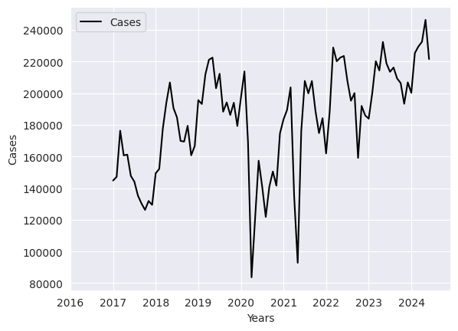

Fig. 1 Plot of actual data over time

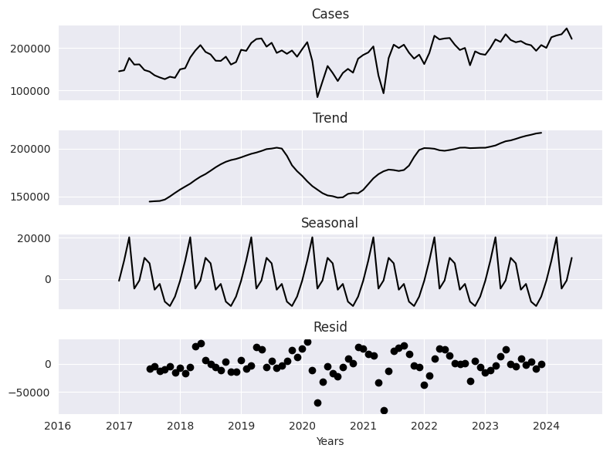

Fig. 2 Seasonal decomposition of TB cases

**3.1 SARIMA Model**

The SARIMA model's training data comprises 80% of the TB dataset, with the remaining 20% set aside for testing the model's predictive performance. Non-stationarity was first shown by the Augmented Dickey Filler (ADF) test (test statistic=-2.44, p=0.12(>0.05)). Initial parameter estimates for the SARIMA model were obtained from Autocorrelation Function (ACF) and Partial Autocorrelation Function (PACF) charts which are given in Fig.3 and Fig.4. The series became stable with the application of first-order seasonal differencing, which was shown in Fig.5 (test statistic=-3.49, p=0.008(<0.05)). The best model was found using auto_arima to be (1,0,1) (1,0,0)12, with AIC=1446.365 and BIC=1461.367. Residual plot, ACF plot, and Kernel Density Estimation (KDE) plot were depicted in Fig.6(a) and used for residual diagnostics of the chosen parameters (1,0,1) (1,0,0)12, which verified that the residuals had little autocorrelation and were almost white noise.

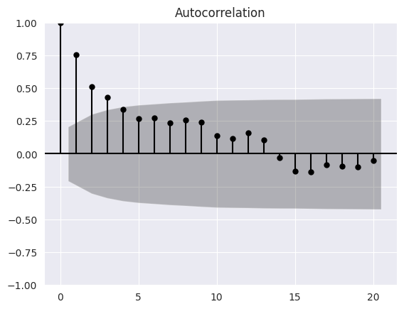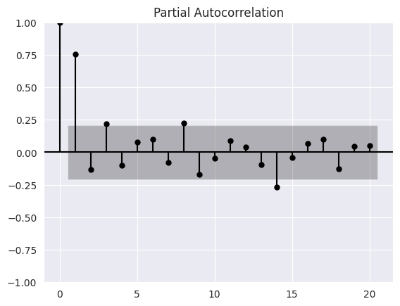

Fig.3 ACF Plot Fig.4 PACF Plot

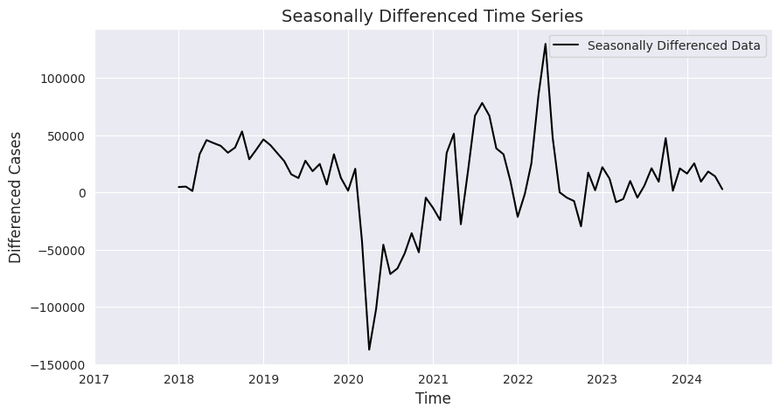

Fig.5 Seasonally differenced time plot

**3.2 ARNN Model**

Seasonality in the time series affected the selection of P. In order to take into consideration recurrent seasonal patterns, P was set to 1 by combining data from one previous seasonal cycle. The value of p is chosen between 1 and 10 based on lower accuracy metrics, and the parameters were selected as (1,1,2)12​, as ARNN (1,1,2)12​ proved to be the best model based on RMSE, MAE, and MAPE across both training and testing sets Fig.6(b). presents the residual plot, ACF plot of residuals and KDE plot, which were utilized for residual diagnostics and exhibits a downward trend over time and minimal autocorrelation.

**3.3 Hybrid (SARIMA-ARNN) Model**

Initially modeled the time series data using a SARIMA model with parameters (1,0,1) (1,0,0)12, chosen by the auto_arima function. The residuals from the SARIMA model were then fed into an NNAR model to employ neural networks in capturing any nonlinear trends. Combining the corrected residuals generated by the NNAR model with the SARIMA forecasts yielded the final projections for the time series. The residual diagnostics depicted in Fig.6(c) indicate that the residuals demonstrate a degree of autocorrelation.

**3.4 BSTS Model**

The BSTS model was applied to project tuberculosis trends in India. With trend and seasonal components, the model efficiently captured underlying seasonal patterns. Strong predictive accuracy was shown by evaluation of the test set producing an RMSE, MAPE, and MAE. Furthermore, validating the model's reliability was training set metrics. Forecasts against real-world data visual analysis confirmed even more the capacity of the model to reflect intricate dynamics in tuberculosis incidence. Fig.6(d). illustrates that the residual diagnostics suggest a certain degree of autocorrelation.

The forecast vs actual diagrams for SARIMA, NNAR, Hybrid, and BSTS models are depicted in Fig.7(a), (b), (c), (d). Each model is designed to predict the prevalence of tuberculosis over a period of time. As relying solely on visual examination can be deceptive, every model's performance measurement should be taken into account. The evaluation results of the models are presented in Table 1., in which RMSE, MAE and MAPE for both training and testing sets were presented. Based on the comparison, the BSTS model exhibits the highest level of accuracy.

Table 1. Performance metrics of all the models

|  |  |  |  |  |  |  |
| --- | --- | --- | --- | --- | --- | --- |
| MODEL | Training sets | | | Testing sets | | |
| RMSE | MAE | MAPE | RMSE | MAE | MAPE |
| SARIMA (1,0,1)(1,0,0)12 | 37784.08 | 31718.34 | 15.41 | 52272.38 | 47273.80 | 21.48 |
| ARNN(1,1,2)12 | 44689.25 | 38890.91 | 22.05 | 46753.16 | 46516.68 | 36.85 |
| Hybrid | 112623.56 | 109522.93 | 64.28 | 35198.86 | 32081.66 | 14.53 |
| BSTS | 36753.06 | 29190.91 | 19.69 | 27634.42 | 23300.73 | 10.55 |

**4 DISCUSSIONS**

The study evaluated four predictive modeling approaches such as SARIMA, ARNN, hybrid model, and BSTS for tuberculosis incidence predictions in India. Comparative analysis shows that BSTS exhibits higher precision for TB case prediction based on the 2017-2024 monthly prevalence. A comprehensive evaluation of all models' forecasting accuracy is presented in Table 1. The BSTS model leverages Bayesian inference to combine prior knowledge with trend, seasonal, and regression components, offering a robust framework for analyzing complex data patterns (Zhang et al., 2024)[18]. This model minimizes overfitting through MCMC-based component optimization, enhancing forecast accuracy by dynamically updating latent states and their probability distributions. The results identified a consistent epidemiological pattern: case numbers peaked during the second quarter (April-June) before declining significantly in the fourth quarter (October-December). Similarly, various studies have established that TB transmission exhibits distinct seasonal variations, with research consistently showing periodic fluctuations in case incidence (Kumar et al., 2014; Narula et al., 2015)[25,26]. The transmission cycles and seasonal patterns influencing infection rates were highlighted for TB trends from 2001 to 2021 in a Brazilian paper and the outcomes were predicted till 2030 using time series methods (Silva & Galvão, 2024)[27].

In this research SARIMA (1,0,1) (1,0,0)12 model is employed to analyze and forecast TB incidence, demonstrating reasonable performance. The model achieved RMSE, MAE, and MAPE values of 52272.38, 47273.80 and 21.48 for test set. However, these SARIMA metrics were lower than that of the BSTS model's metrics which are 27634.42, 23300.73, 10.55 for the same set. While SARIMA is limited to identifying linear patterns in data, BSTS excels by incorporating nonlinear components such as trends, seasonality, covariates, and residual errors, making it more effective for infectious disease prediction.

The BSTS model outperformed SARIMA in predicting monthly malaria incidence because it captured the complex links between climate and the disease in a related study. SARIMA's fixed structure did not yield as precise outbreak predictions as the Bayesian approach, which facilitated targeted public health interventions (Vavilala et al., 2022)[28].

Similar to SARIMA, the ARIMA model also shows lower accuracy compared to BSTS when evaluating how well vaccines reduce infection rates(Navas Thorakkattle et al., 2022) [11].

This study also utilized an ARNN (1,1,2)12 model to forecast TB incidence. The model produced RMSE, MAE, and MAPE values of 46753.16, 46516.68 and 36.85 for the test set, which shows higher accuracy than that of the BSTS model’s metrics. Despite ARNN’s ability to model nonlinear patterns, it faces several limitations.

Neural networks' limitations in time series forecasting, addressing issues like seasonality and non-stationarity through different architectures were uncovered by a comparable study. The authors analyze these challenges and conclude that the traditional statistical models may perform better than neural network models when there is data sufficiency the datasets face issues in the model fitting(Andrea Sánchez-Sánchez et al., n.d.) [10]. Statistical models perform better than ML models in forecasting, particularly with limited data, because with the small datasets, they are easier to understand and more dependable. While ML detects complex patterns well, it risks overfitting and lacks interpretability. For most predictions, statistical methods prove more dependable, though hybrid approaches may combine their strengths (Makridakis et al., 2018)[29].

In a similar study, the BSTS model demonstrated a 17-23% increase in accuracy over the NNAR model in the prediction of Kuwait's air passenger volumes. This was attributed to the BSTS model's superior handling of structural breaks and uncertainty quantification (Al-Sultan et al., n.d.)[30].

The BSTS model which shows better results than machine learning approaches for disease surveillance was evaluated in a comparable study. BSTS provides superior interpretability for causal analysis with sparse data, whereas ML techniques detect complex patterns better when abundant training data exist (Babanejaddehaki et al., n.d.)[31]

In disease and epidemic modelling research, the standard SARIMA formulation serves as a commonly adopted analytical approach. The BSTS model was the most accurate of the group, surpassing the other models in terms of comparison criteria. The developed models were exclusively trained on Indian data spanning January 2017 to June 2024. Consequently, these findings require careful revaluation with extended time-series data in subsequent research.

**5 Conclusion**

This study compared four models (SARIMA, ARNN, Hybrid SARIMA-ARNN, BSTS) for TB forecasting in India. The BSTS model excelled with the lowest error metrics, adeptly handling trends and seasonality via MCMC sampling. While the Hybrid model was promising, SARIMA and ARNN models failed to perform adequately with complex patterns. The study underscored the importance of solving non-stationarity through differencing and transformations, with PACF plot, ACF plot, and auto_arima assisting in parameter optimization. To capture non-linear components, manual calibration was necessary for ARNN. Results support BSTS for public health planning, enabling targeted TB interventions. Future work can be to refine hybrids and explore advanced ML. BSTS emerges as the optimal model for India's TB incidence prediction.

**References**

[1] Cleveland, J. L., Robison, V. A., & Panlilio, A. L. (2009). Tuberculosis epidemiology, diagnosis and infection control recommendations for dental settings: an update on the Centers for Disease Control and Prevention guidelines. *The Journal of the American Dental Association*, *140*(9), 1092-1099.

[2] Ahmad, S. (2010). New approaches in the diagnosis and treatment of latent tuberculosis infection. *Respiratory research*, *11*, 1-17.

[3] World Health Organization (WHO). (2024). *Global Tuberculosis Report 2024.*

[4] Central Tuberculosis Division, Ministry of Health and Family Welfare, Government of India. (2024). *India TB Report [2024].*

[5] Aydin, S. (2022). Time series analysis and some applications in medical research. *Journal of Mathematics and Statistics Studies*, *3*(2), 31-36.

[6] Yu, L., Zhou, L., Tan, L., Jiang, H., Wang, Y., Wei, S., & Nie, S. (2014). Application of a new hybrid model with seasonal auto-regressive integrated moving average (ARIMA) and nonlinear auto-regressive neural network (NARNN) in forecasting incidence cases of HFMD in Shenzhen, China. *PloS one*, *9*(6), e98241.

[7] Wang, H., Tian, C. W., Wang, W. M., & Luo, X. M. (2018). Time-series analysis of tuberculosis from 2005 to 2017 in China. *Epidemiology & Infection*, *146*(8), 935-939.

[8] Almarashi, A. M., Daniyal, M., & Jamal, F. (2024). A novel comparative study of NNAR approach with linear stochastic time series models in predicting tennis player's performance. *BMC Sports Science, Medicine and Rehabilitation*, *16*(1), 28.

[9] Yu, G., Feng, H., Feng, S., Zhao, J., & Xu, J. (2021). Forecasting hand-foot-and-mouth disease cases using wavelet-based SARIMA–NNAR hybrid model. *PLoS one*, *16*(2), e0246673.

[10] Sánchez-Sánchez, P. A., García-González, J. R., & Coronell, L. H. P. (2019). Encountered problems of time series with neural networks: Models and architectures. In *Recent Trends in Artificial Neural Networks-from Training to Prediction*. IntechOpen.

[11] Navas Thorakkattle, M., Farhin, S., & Khan, A. A. (2022). Forecasting the trends of covid-19 and causal impact of vaccines using bayesian structural time series and arima. *Annals of Data Science*, *9*(5), 1025-1047.

[12] Kam, H. J., Sung, J. O., & Park, R. W. (2010). Prediction of daily patient numbers for a regional emergency medical center using time series analysis. *Healthcare informatics research*, *16*(3), 158-165.

[13] Pennsylvania State University. (n.d.). *4.1 Stationarity and Differencing.* STAT 510: Applied Time Series Analysis. Retrieved from <https://online.stat.psu.edu/stat510/lesson/4/4.1>

[14] Talkhi, N., Fatemi, N. A., Ataei, Z., & Nooghabi, M. J. (2021). Modeling and forecasting number of confirmed and death caused COVID-19 in IRAN: A comparison of time series forecasting methods. *Biomedical signal processing and control*, *66*, 102494.

[15] Reza, A., & Debnath, T. (2020). An approach to make comparison of ARIMA and NNAR Models for Forecasting Price of Commodities. *Res. Gate*.

[16] Baikunth, B. K. Y., Sunil, S. K. S., & Pranveer, P. S. (2022). Forecasting seasonality and trend of tuberculosis prevalence in India using SARIMA-NNAR Hybrid model.

[17] Roth, J., Chadalawada, J., Jain, R. K., & Miller, C. (2021). Uncertainty matters: Bayesian probabilistic forecasting for residential smart meter prediction, segmentation, and behavioral measurement and verification. *Energies*, *14*(5), 1481.

[18] Zhang, F., Li, Y., Li, X., Zhang, B., Xue, C., & Wang, Y. (2024). Comparison of ARIMA and Bayesian Structural Time Series Models for Predicting the Trend of Syphilis Epidemic in Jiangsu Province. *Infection and Drug Resistance*, 5745-5754.

[19] Almarashi, A. M., & Khan, K. (2020). Bayesian structural time series. *Nanoscience and Nanotechnology Letters*, *12*(1), 54-61.

[20] Scott, S. L., & Varian, H. R. (2014). Predicting the present with Bayesian structural time series. *International Journal of Mathematical Modelling and Numerical Optimisation*, *5*(1-2), 4-23.

[21] Katzfuss, M., Stroud, J. R., & Wikle, C. K. (2016). Understanding the ensemble Kalman filter. *The American Statistician*, *70*(4), 350-357.

[22] Haqbin, S. R. K., & Khan, A. A. (2024). Bayesian Prediction of Afghanistan Annual Population Growth Using ARIMA and BSTS Models.

[23] Zhou, L., Zhao, P., Wu, D., Cheng, C., & Huang, H. (2018). Time series model for forecasting the number of new admission inpatients. *BMC medical informatics and decision making*, *18*, 1-11., Chicco, D., Warrens, M. J., & Jurman, G. (2021).

[24] The coefficient of determination R-squared is more informative than SMAPE, MAE, MAPE, MSE and RMSE in regression analysis evaluation. *Peerj computer science*, *7*, e623.

[25] Kumar, V., Singh, A., Adhikary, M., Daral, S., Khokhar, A., & Singh, S. (2014). Seasonality of tuberculosis in Delhi, India: a time series analysis. *Tuberculosis research and treatment*, *2014*(1), 514093.

[26] Narula, P., Sihota, P., Azad, S., & Lio, P. (2015). Analyzing seasonality of tuberculosis across Indian states and union territories. *Journal of epidemiology and global health*, *5*(4), 337-346.

[27] Silva, M. T., & Galvão, T. F. (2024). Tuberculosis incidence in Brazil: time series analysis between 2001 and 2021 and projection until 2030. *Revista Brasileira de Epidemiologia*, *27*, e240027.

[28] Vavilala, H., Yaladanda, N., Krishna Kondeti, P., Unissa, R., Mopuri, R., Gouda, K. C., ... & Rao Mutheneni, S. (2022). Weather integrated malaria prediction system using Bayesian structural time series model for northeast states of India. *Environmental Science and Pollution Research*, *29*(45), 68232-68246.

[29] Makridakis, S., Spiliotis, E., & Assimakopoulos, V. (2018). Statistical and Machine Learning forecasting methods: Concerns and ways forward. *PloS one*, *13*(3), e0194889.

[30] Al-Sultan, A., Al-Rubkhi, A., Alsaber, A., & Pan, J. (2021). Forecasting air passenger traffic volume: evaluating time series models in long-term forecasting of Kuwait air passenger data. *Advances and Applications in Statistics*, *70*(1), 69-89.

[31] Babanejaddehaki, G., An, A., & Papagelis, M. (2025). Disease Outbreak Detection and Forecasting: A Review of Methods and Data Sources. *ACM Transactions on Computing for Healthcare*, *6*(2), 1-40